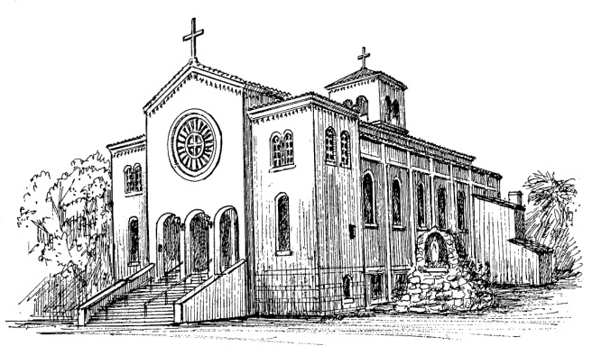
Our Lady Help of Christians
“PARROQUIA MARIA AUXILIADORA”
2401 East Lake Avenue
Watsonville CA 95076
Telephone (831)722-2665

Mass Intention Request Date TIME
For: 1. ________________________ _______ _______
2._______________________ ________ ______
3. _______________________ _______ _______
4._______________________ ________ _______
5.________________________ ________ _______
6. _________________________ ________ _______
DEcEASED □ BLESSINGS □ BIRTHDATE □ Health □
For INTENTIONS □ WEDDING ANNIVERSARY □ In tHANKSGIVING □
Requested By: __________________________________
Address: _______________________________________

Office use onlY
Received By: _____________DATE__________________
Receipt #_________________ $ ___________________

